

Semester 2, Session 2025/2026
SCSE2243 APPLICATION DEVELOPMENT I
SECTION 01
PROJECT PROPOSAL

UTM BORROW

A Campus-Wide Circular Resource Sharing Platform
Prepared For | DR. MOHD YAZID BIN IDRIS
Submission Date | 14 - APRIL 2026
Group Name | Alpha

NAME | MATRIC NUMBER
MOHAMMED MOHSEN MOHAMMED ALSAKKAF | A23CS4026
MUAZ IBNE AHMED | A23CS4062
AHMAT MAHAMAT MOURDJI MOUSTAPHA | A24CS4053

Faculty of Computing, Universiti Teknologi Malaysia

Table of Content
1. EXECUTIVE SUMMARY 2
2. PROJECT DOMAIN AND COMMUNITY BACKGROUND 3
2.1. The Current Problem Space 3
2.2. Community and Stakeholder Context 3
3. PROBLEM ANALYSIS 4
3.1. QUESTIONNAIRES 4
3.1.1. Demographic information 4
3.1.2. Buying and selling behavior 4
3.1.3. Buying and selling experience 4
3.1.4. Communication and payment preferences 4
3.1.5. Challenges and satisfaction 4
3.1.6. Trust and platform perception 4
4. PROBLEM STATEMENT 5
4.1. Problem 1: Financial Drain from Single-Use Academic Purchases 5
4.2. Problem 2: Absence of Trust Infrastructure in Existing Sharing Channels 5
4.3. Problem 3: No Accountability Mechanism for Item Returns and Condition 5
4.4. Problem 4: Wasted Campus Resources and Environmental Impact 5
5. GOAL AND OBJECTIVE 6
5.1. Overarching Project Goal 6
5.2. Core Technical Objectives 6
6. PROPOSED APPLICATION 7
6.1. Identity Authentication Subsystem 8
6.1.1. Authentication SSO Module 8
6.1.2. Profile Trust and Merit Points Module 8
6.1.3. Role Access Control (RBAC) Module 8
6.2. Inventory and Listing Subsystem 9
6.2.1. Item Listing and Photo Module 9
6.2.2. Geolocation Search Module 9
6.2.3. Category and Condition Metadata Module 9
6.3. Request and Handover Subsystem 10
6.3.1. Request Workflow and Insurance Fee Module 10
6.3.2. QR Token Engine Module 10
6.3.3. Lease Cycle State Machine Module 10
6.4. Administrative Analytics Subsystem 11
6.4.1. Admin Moderation Panel Module 11
6.4.2. Firebase Notification Engine Module 11
6.4.3. BI Sustainability Dashboard Module 11
7. PROPOSED TECHNOLOGY AND TOOLS USED 12
7.1. Modeling & Project Management Tools 12
7.2. Project Management and Collaboration (Jira, GitHub, Visual Paradigm) 12
8. PROJECT BENEFITS 13
8.1. Benefits for UTM Students (Financial & Space) 13
8.2. Benefits for UTM Administration and UTMCS 13
8.3. Environmental Impact for the University 13
9. PROJECT SCHEDULE 14
10. TEAM MEMBERS AND ROLES 14
10.1. Subsystems and Responsible Team Members 14
10.2. Waterfall Phase Responsibilities 14
11. INDIVIDUAL SCHEDULE 15
11.1. [MEMBER A NAME] — : Identity Authentication 15
11.2. [MEMBER B NAME] — : Inventory and Listing 15
11.3. [MEMBER C NAME] — : Request and Handover 15
11.4. [MEMBER D NAME] —: Administrative Analytics 15

EXECUTIVE SUMMARY
This project proposes a new mobile application called UTM Borrow, designed specifically as a circular resource-sharing platform for the Universiti Teknologi Malaysia (UTM) community. The main goal is to facilitate a secure, centralized environment where students and staff can lend and borrow academic resources such as laboratory tools, engineering equipment, textbooks, and event clothing. Currently, students face severe financial constraints purchasing single-use expensive tools, while campus sustainability suffers from post-semester disposal waste.
Unlike unverified WhatsApp or Telegram groups, UTM Borrow introduces strict trust mechanics. The system authenticates users via the official UTM Single Sign-On (SSO) and manages item handovers utilizing cryptographic QR code scanning to guarantee accountability and ensure items are safely returned.
In alignment with the course syllabus, this project will follow a sequential Software Development Life Cycle (SDLC) process, culminating in a fully interactive, High-Fidelity Prototype. The development methodology incorporates Generative AI for modern requirement engineering, Visual Paradigm for rigorous UML system modeling, and Figma for collaborative UI/UX frontend prototyping. To distribute the workload evenly, the application architecture is divided into four distinct subsystems: Identity Authentication, Inventory Listing, Request & Handover, and Administrative Analytics, with each subsystem managed by a dedicated team member.

PROJECT DOMAIN AND COMMUNITY BACKGROUND

The Current Problem Space
The student community at Universiti Teknologi Malaysia (UTM) frequently encounters financial barriers due to short-term academic requirements. Many courses and extracurricular activities require students to acquire specific, high-cost items—such as scientific laboratory equipment, engineering drawing tools, formal presentation attire, or specialized electronics—that are often only utilized for a single semester or project.
Currently, the primary ecosystem for acquiring these temporary items relies on new purchases or unstructured peer-to-peer sharing via informal channels like Telegram or WhatsApp. These channels are heavily fragmented, unmoderated, and lack basic trust mechanisms, resulting in buried requests, potential scams, and high anxiety for lenders. Consequently, the absence of a centralized borrowing platform leads to redundant purchases, financial strain on lower-income students, and the accumulation of post-semester waste across residential colleges

Community and Stakeholder Context
UTM Borrow establishes a localized circular economy that actively benefits three main stakeholders within the campus ecosystem:
- Student Borrowers: Students seeking cost-effective, temporary access to academic and lifestyle resources. They require a centralized, easily searchable directory filtered by their residential colleges or faculties to locate available items quickly without financial strain.
- Student Lenders: Students who possess underutilized resources. To confidently lend their assets, they require a secure, verified environment with identity tracking, QR handover protocols, and rating systems to ensure their items are treated with respect and returned promptly.
- UTM Administration/Moderators: University representatives tasked with overseeing student welfare, preventing spam/scams, and achieving sustainability goals. They require analytical dashboards to track usage, measure resource-sharing impacts, and moderate the community, thereby contributing directly to UTM’s "Smart and Green Campus" objectives.

PROBLEM ANALYSIS

To gather information about the problems faced by the community regarding campus resource sharing, our team conducted a distributed questionnaire.

QUESTIONNAIRES
We distributed our questionnaire to reach UTM students across different levels and faculties. Eventually, we managed to gather 29 responses.

Demographic information

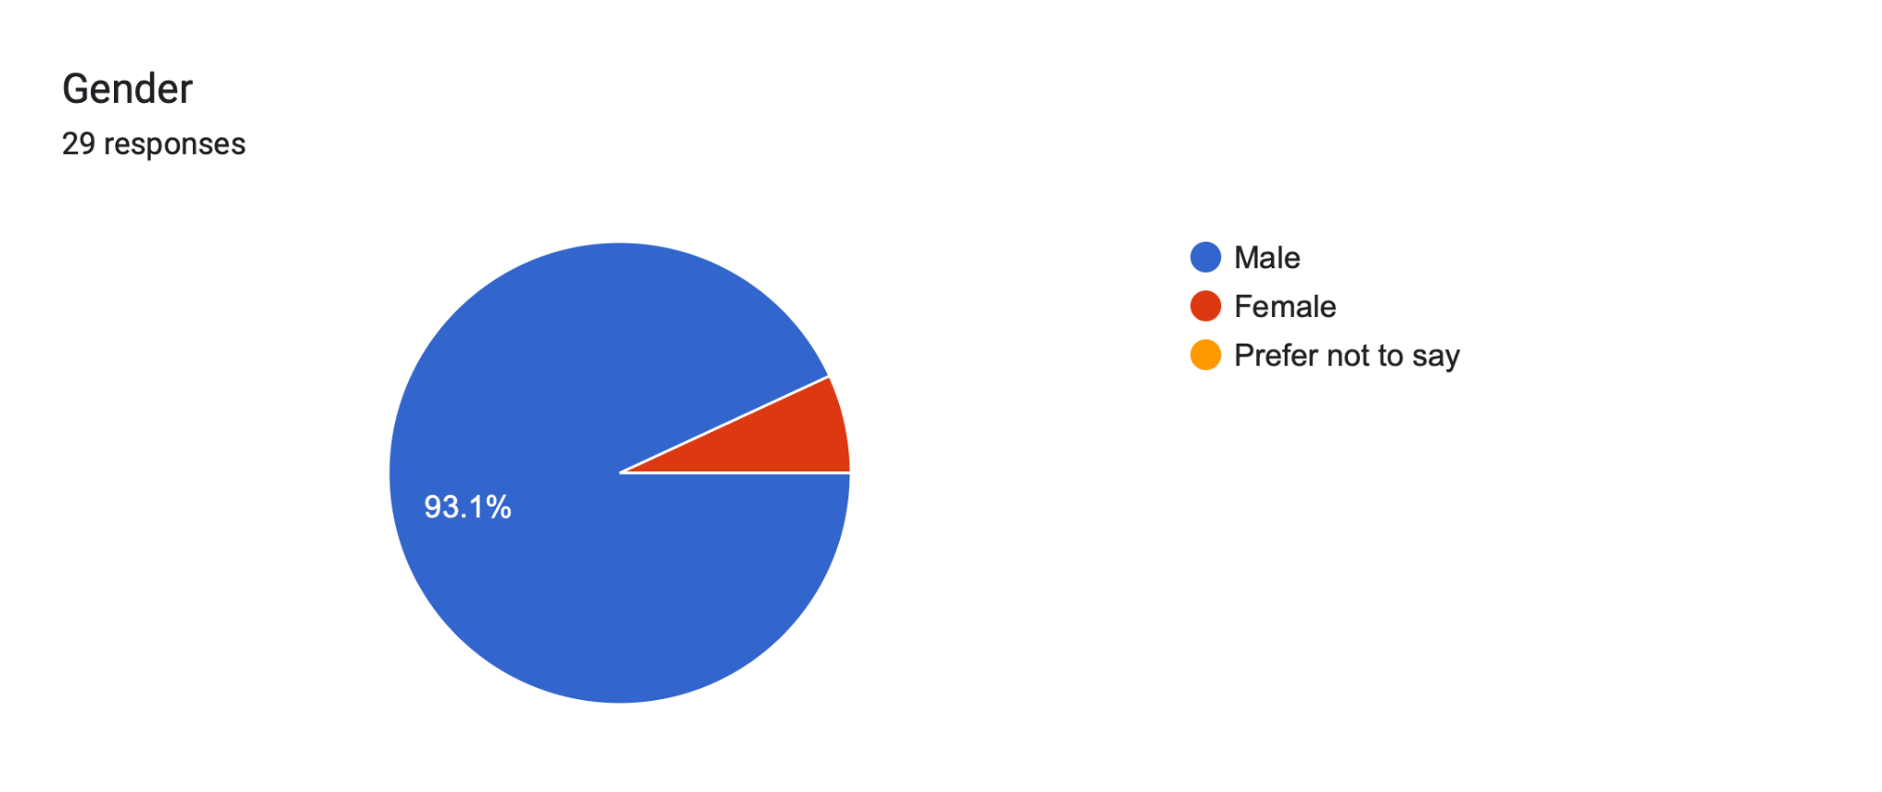
Figure 3.1: Gender distribution of respondents
Based on Figure 3.1, a total of 29 respondents participated in the survey. Among them, 93.1% were male. This indicates that the vast majority of participants were male students, providing a specific baseline for our initial target audience analysis.
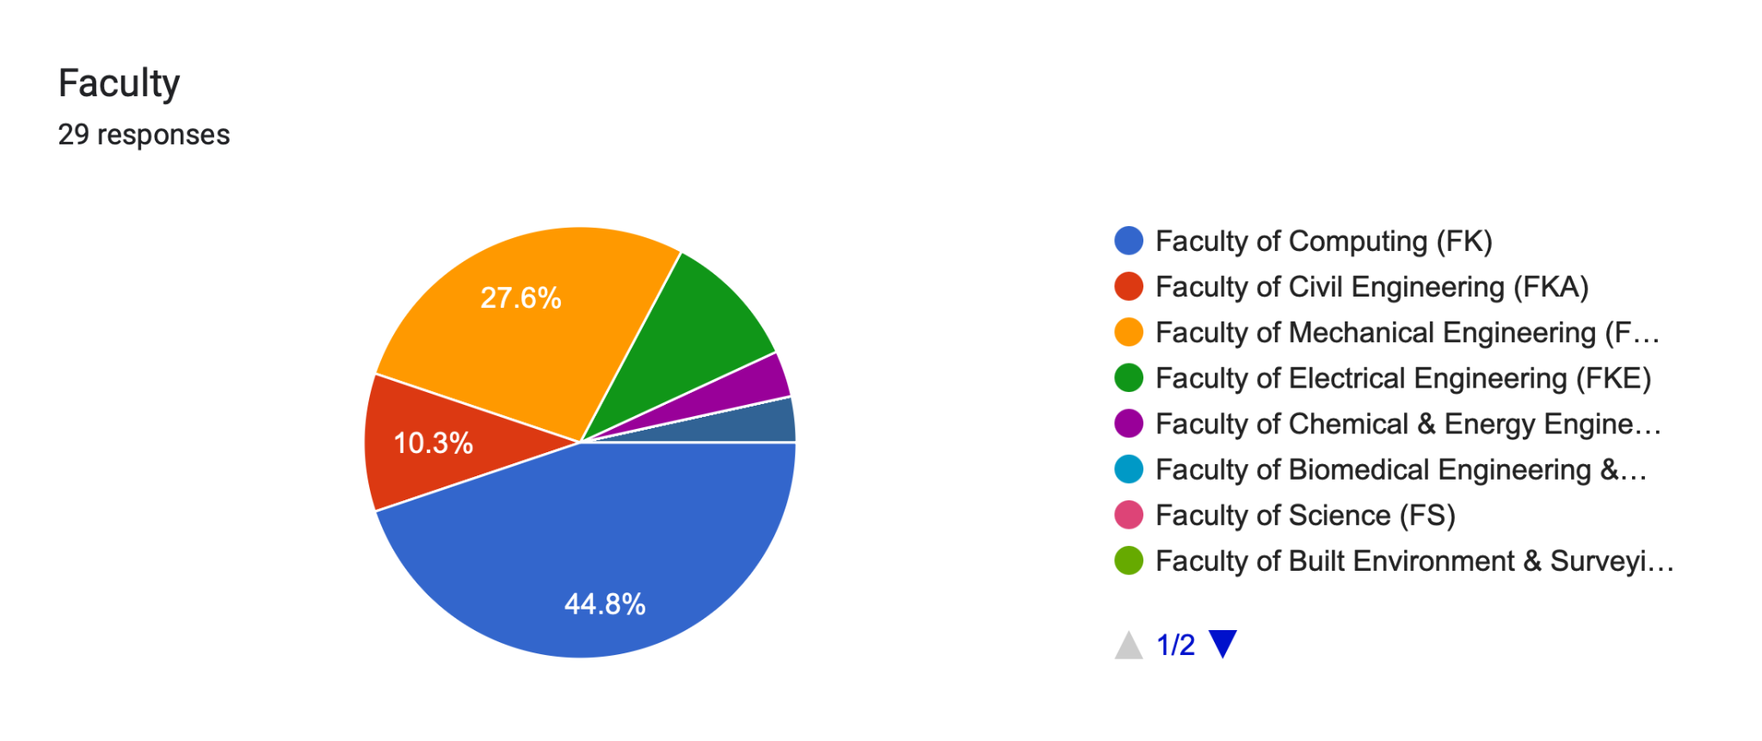 Figure 3.2: Faculty distribution of respondents

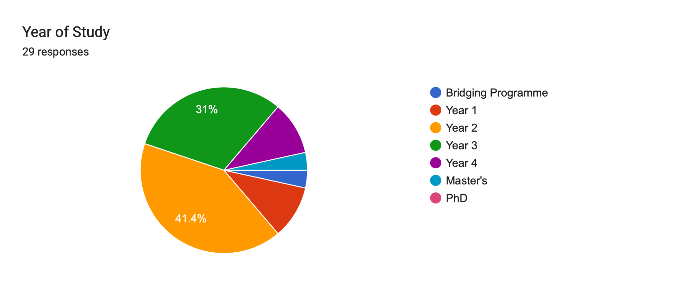Figure 3.3: Year of study distribution

The survey results show that a significant portion of respondents are from the Faculty of Computing (44.8%), followed by the Faculty of Civil Engineering (27.6%). Regarding their academic progress, 41.4% are Year 3 students, and 31% are Year 4 students. This indicates that upper-year engineering and computing students form the bulk of our respondents, likely due to their frequent need for specialized project materials and laboratory equipment.

Buying and selling behavior
Frequency of purchasing single-use academic items
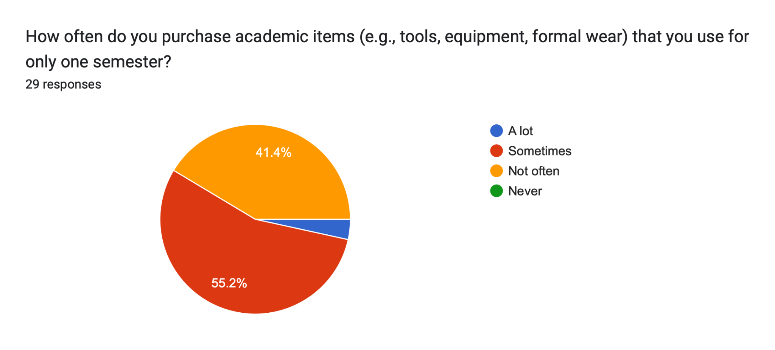
Figure 3.4: Frequency of purchasing items used for only one semester
Figure 3.4 illustrates how often students purchase academic items (like tools, equipment, or formal wear) that are utilized for only a single semester. The majority (55.2%) do this "Sometimes," while a large segment (41.4%) do it "A lot". This highlights a pervasive "buy-and-discard" culture on campus, confirming the strong need for a circular borrowing platform.
Money spent on one-time items
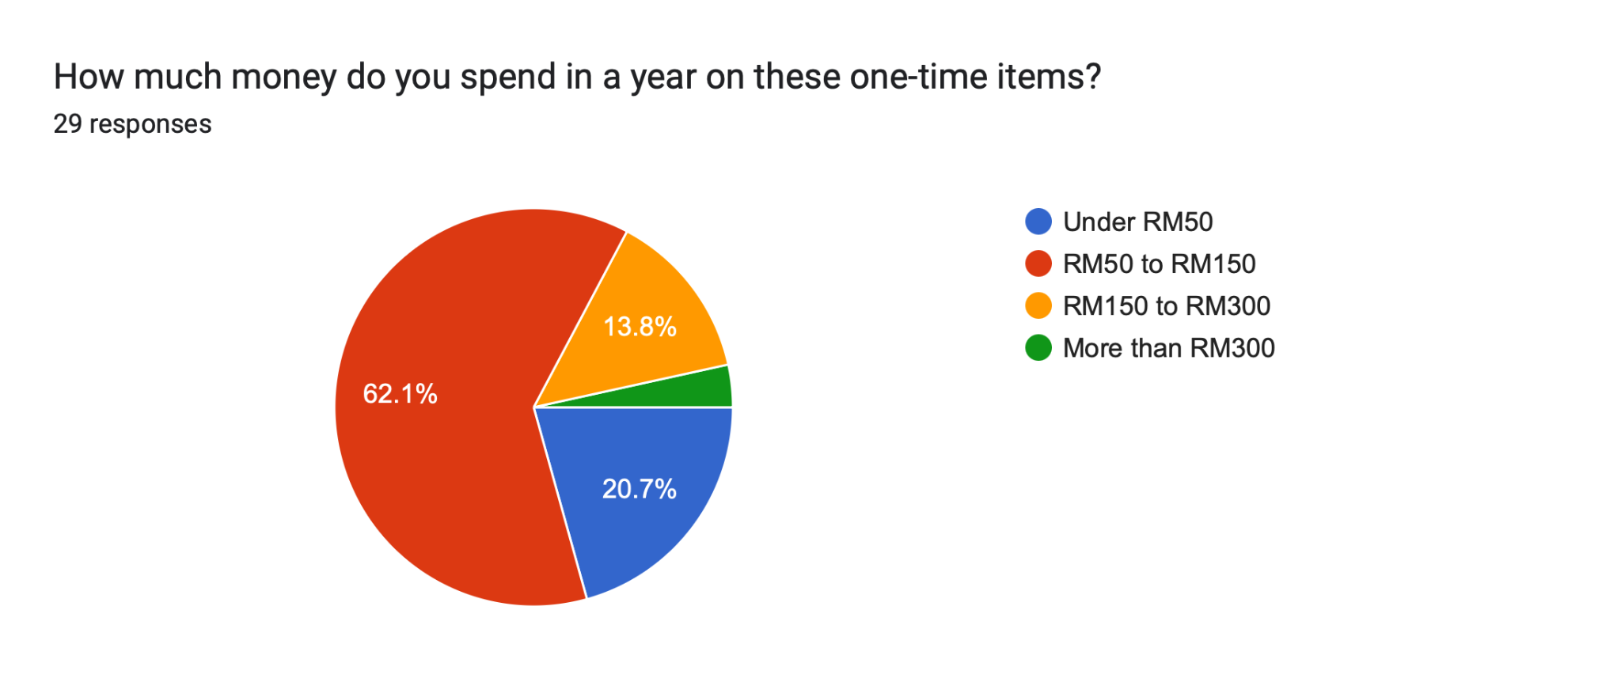
Figure 3.5: Annual expenditure on single-use items
According to Figure 3.5, 62.1% of students spend between RM50 to RM150 annually on these short-term items, and 20.7% spend between RM150 to RM300. This demonstrates the financial drain single-use purchases cause, underscoring the potential cost savings UTM Borrow can provide to the student body.
Reasons for keeping old items
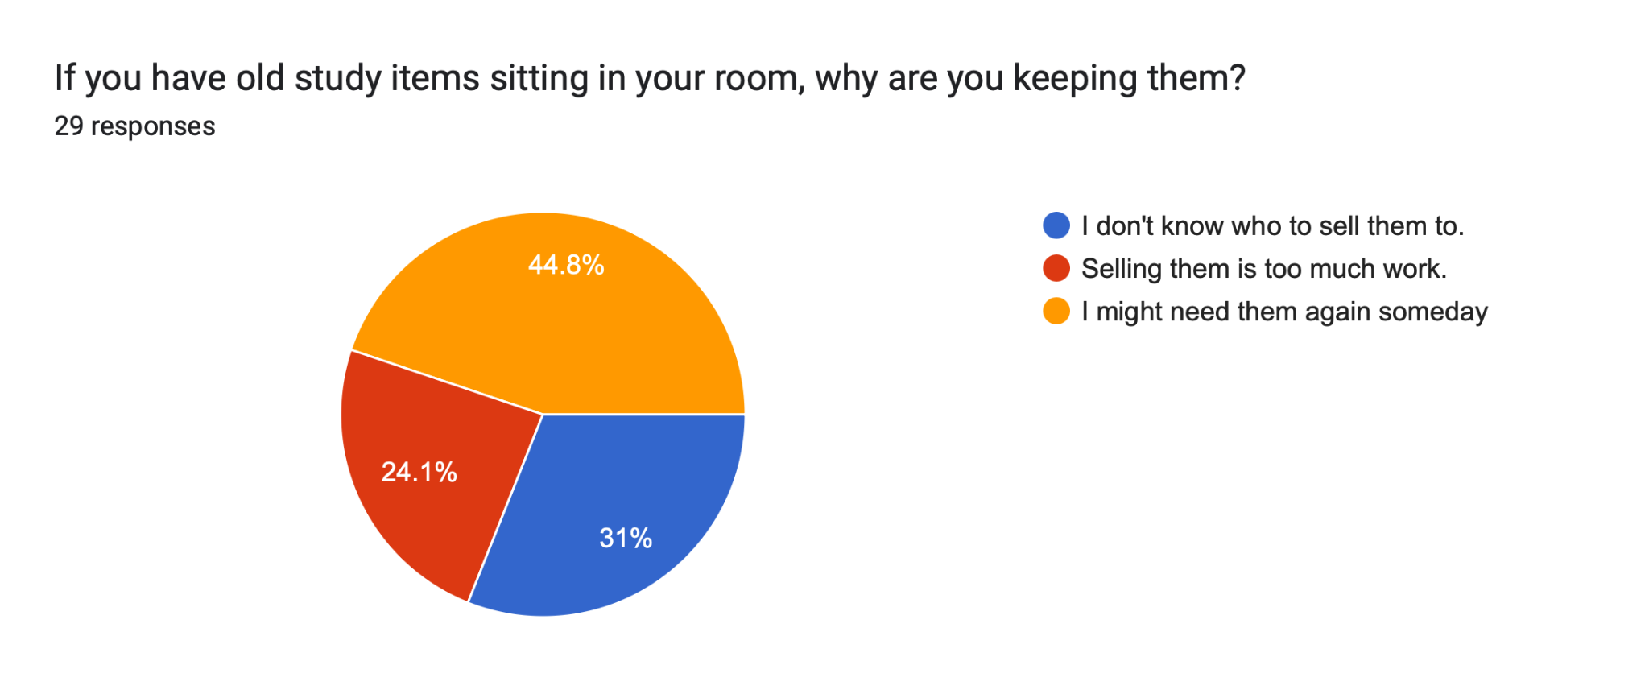
Figure 3.6: Reasons for holding onto old study items
When asked why they keep old study items in their rooms, 44.8% stated they "might need them again someday," 31% "don't know who to sell them to," and 24.1% feel "selling them is too much work". This indicates that a massive latent supply of shareable resources currently exists in dormitories, hindered only by the friction of finding borrowers.

COMMUNICATION AND PAYMENT PREFERENCES
Preferred Digital Payment Method
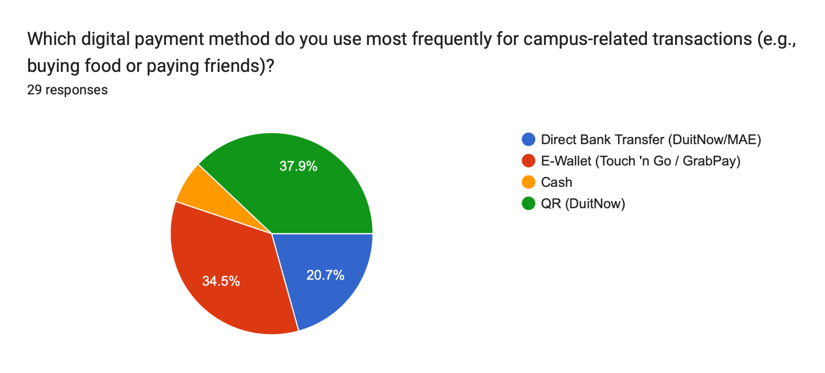
Figure 3.7: Preferred payment methods for campus transactions
Figure 3.7 reveals that E-Wallets (Touch 'n Go / GrabPay) are the most preferred payment method at 37.9%, closely followed by QR (DuitNow) at 34.5% and Direct Bank Transfer at 20.7%. These findings strongly support the integration of flexible, digital-first escrow and deposit systems within the UTM Borrow app.

CHALLENGES AND SAFETY CONCERNS
Efficiency of finding items
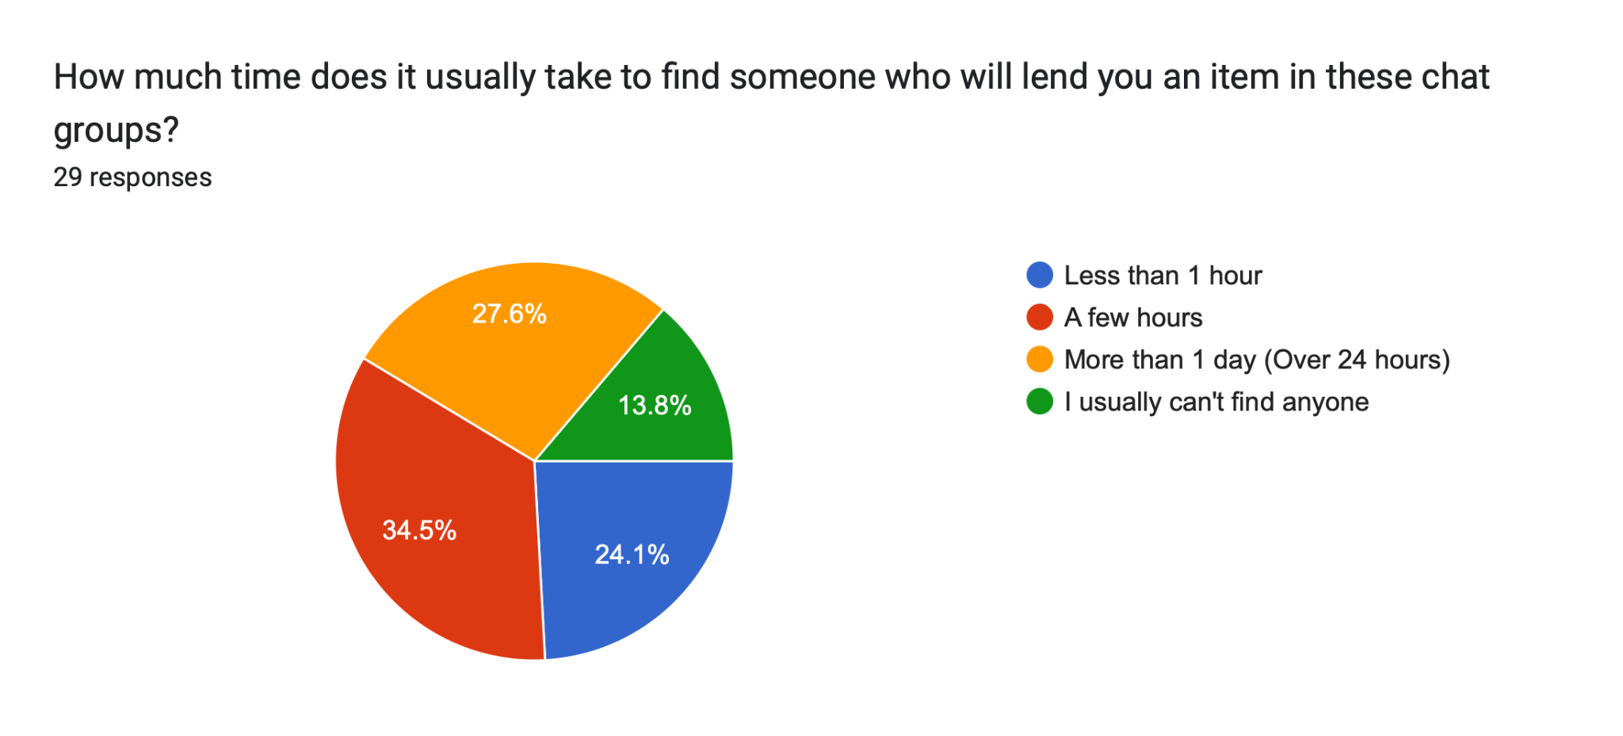
Figure 3.8: Time required to find lenders in existing chat groups
Figure 3.8 highlights the inefficiency of current sharing methods. 34.5% of students take more than 1 day to find an item, and 24.1% usually cannot find anyone at all. This validates the critical need for our localized Geolocation Search Module and Category Metadata Module.
Biggest fear when lending
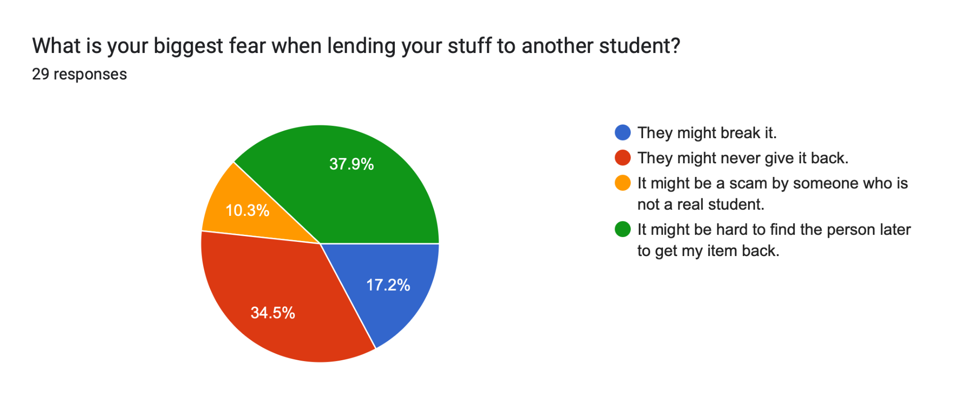
Figure 3.9: Primary concerns when lending items to other students
When lending items, the biggest fear is that the borrower "might never give it back" (37.9%), followed by the concern that "it might be hard to find the person later" (34.5%). Additionally, 55.2% of users currently only rely on "screenshots of our chat" as proof if an item breaks, and 31% have "no real proof at all". This massive lack of accountability justifies the need for UTM Borrow's digital condition logs and formal handover protocols.

TRUST AND PLATFORM PERCEPTION
Handling valuable items and deposits
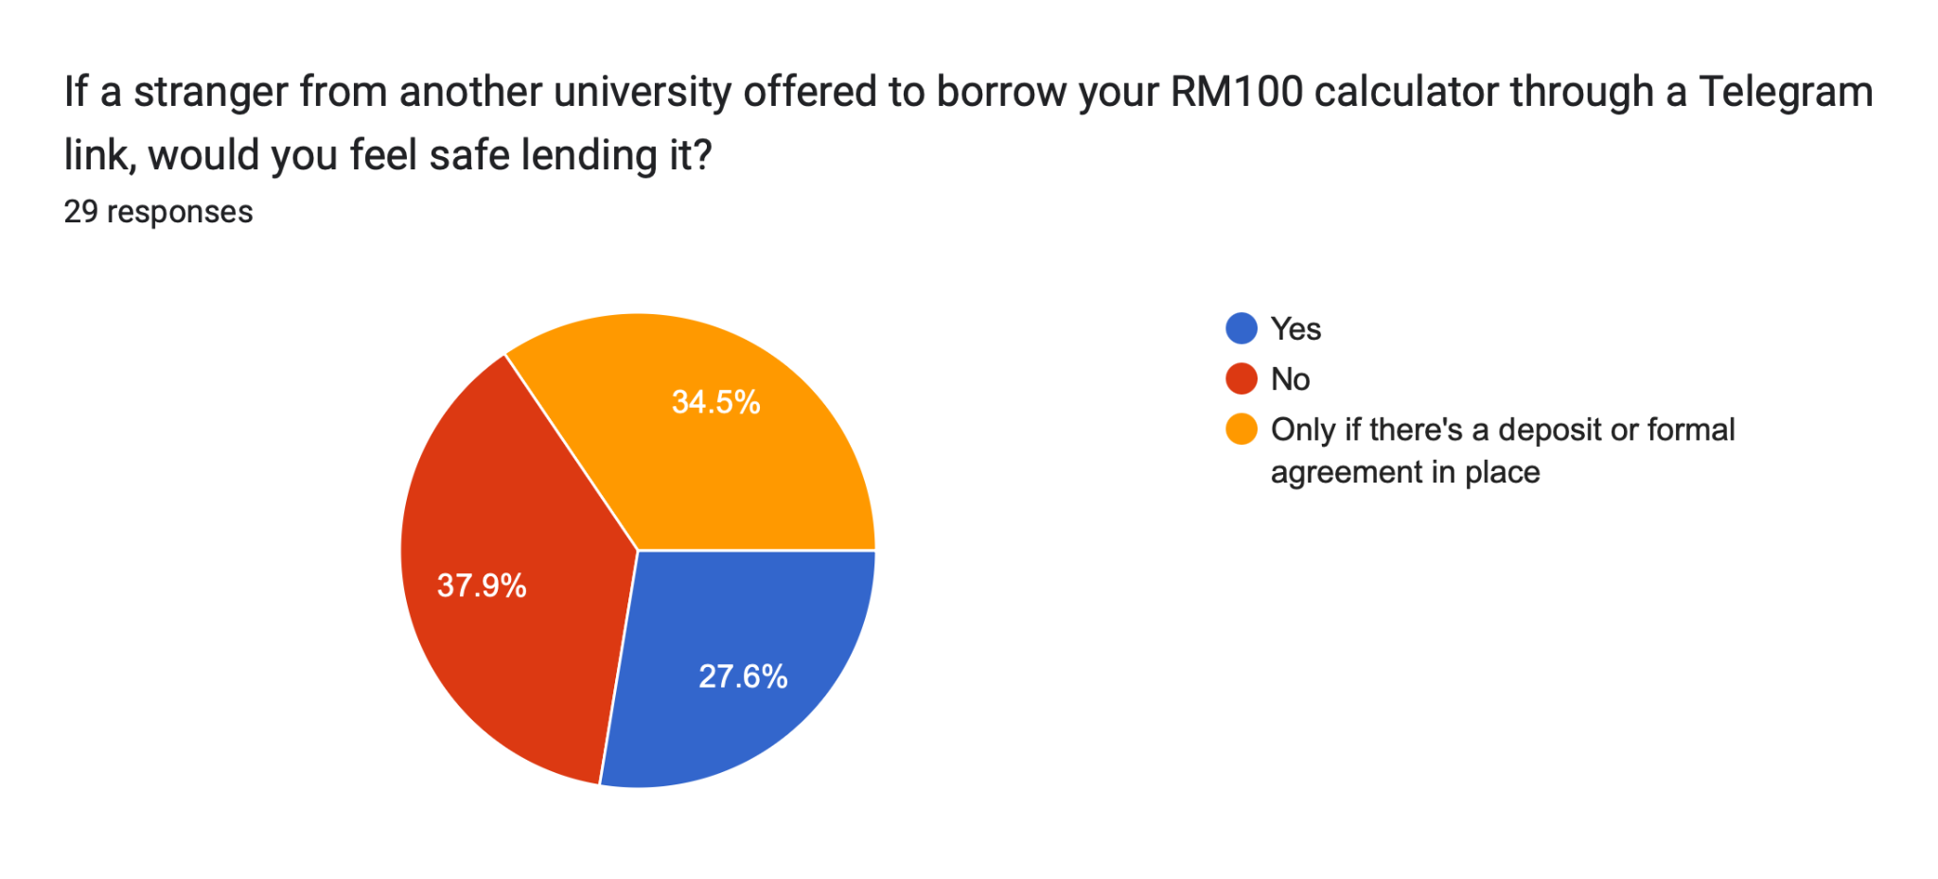
Figure 3.10: Preferences for ensuring the safe return of expensive items
When lending items worth over RM100, the largest group (37.9%) prefers a system that automatically "holds a deposit" until the item is safely returned. Furthermore, when dealing with strangers via Telegram links, 37.9% feel unsafe, and 27.6% would only proceed with a formal agreement.
Desired Application Features
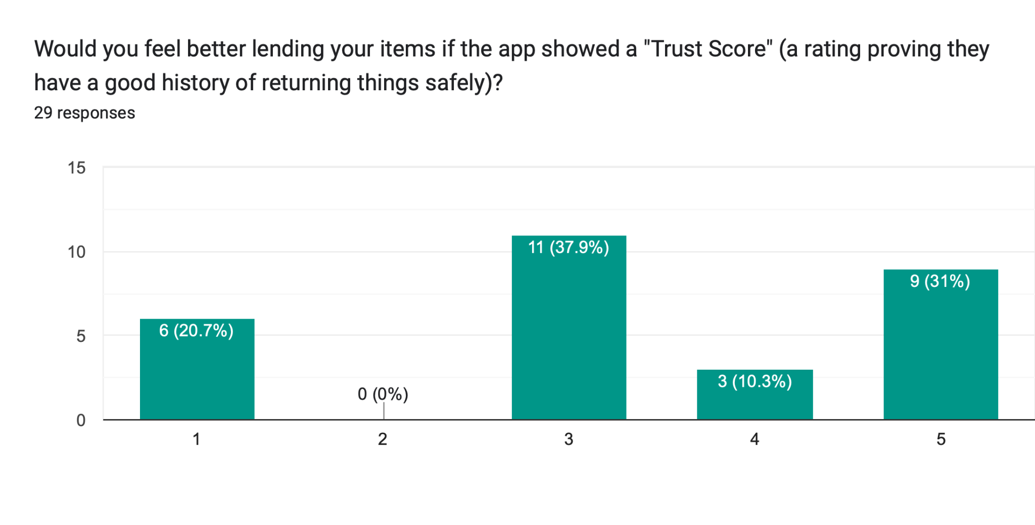
Figure 3.11: Receptiveness to Trust Scores
Respondents showed strong support for systemized safety features. A clear majority rated the implementation of a user "Trust Score" highly (Scores 3 to 5).
Sustainability and Identity Policies
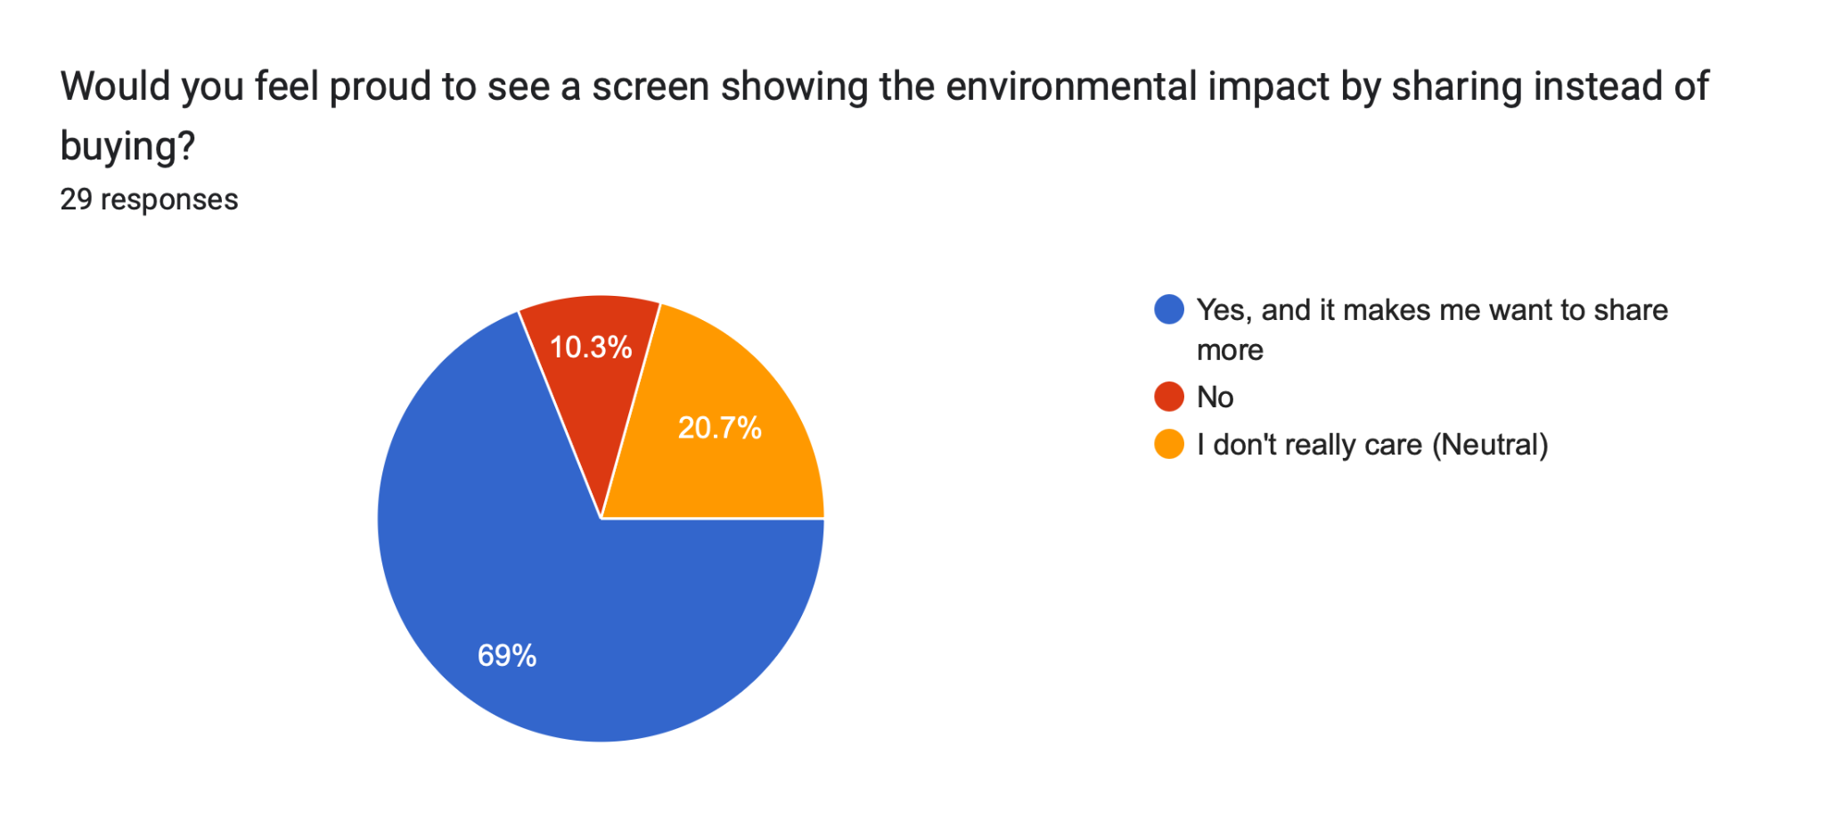

Figure 3.12: Perception of Dashboards and Authentication Policies

A significant 69% of students would feel proud to view an environmental impact dashboard

PROBLEM STATEMENT

Problem 1: Financial Drain from Single-Use Academic Purchases
UTM students face significant financial burdens purchasing specialized academic tools (e.g., lab coats, scientific calculators, presentation attire) for short-term use. The lack of a centralized campus sharing platform forces students to buy these items brand-new, disproportionately affecting those from lower-income backgrounds and exhausting their budgets on items that will lay dormant after one semester.

Problem 2: Absence of Trust Infrastructure in Existing Sharing Channels
Existing methods for peer-to-peer borrowing rely heavily on informal, unverified chat groups such as WhatsApp or Telegram. Because these platforms lack an official identity verification system linked to UTM credentials, students are highly vulnerable to scams and theft by non-affiliates. This profound lack of a trust profile and reputation system actively discourages owners from lending their valuable items.

Problem 3: No Accountability Mechanism for Item Returns and Condition
Campus resource sharing currently operates without formal handover protocols, condition tracking, or strict return deadlines. Lenders frequently face disputes over damaged items because there is no digital baseline or pre-handover photo log. Additionally, without an automated tracking and notification system, items are frequently returned late or completely forgotten, making the sharing process inherently risky for lenders.

Problem 4: Wasted Campus Resources and Environmental Impact
The persistent "buy-and-discard" culture on campus results in immense redundancy, with identical tools repeatedly purchased every semester while perfectly usable equivalents sit idle in dormitories. Without a localized platform and administrative dashboard to monitor resource exchange, the university generates unnecessary academic waste and lacks the data required to track sustainable impact and sharing metrics.

GOAL AND OBJECTIVE

Overarching Project Goal
The goal of this project is to develop UTM Borrow, a secure mobile platform that facilitates a circular economy within the Universiti Teknologi Malaysia community. By transitioning from a "buy-and-discard" habit to a managed borrowing ecosystem, the platform aims to reduce financial barriers for students while promoting university sustainability goals through high-fidelity design and rigorous sequential development.

Core Technical Objectives
- Identity Verification Engine: To implement a secure SSO (Single Sign-On) gateway that ensures all lenders and borrowers are verified UTM affiliates, preventing non-member access.
- Resource Discovery and Geolocation Mapping: Allowing students to efficiently locate nearby items based on residential college zones and faculty locations.
- Accountability and Tokenized Handover: To design a state-machine logic for item tracking, using QR-code tokens to prove physical handover and safe return.
- Administrative Sustainability Dashboard: To establish a backend analytics layer that calculates total cost savings and waste reduction for the UTM Campus Sustainability (UTMCS) department.

PROPOSED APPLICATION
The UTM Borrow System follows a 4-tier modular architecture. This allows each team member to manage the requirements, analysis, and prototyping for a specific core domain of the platform.
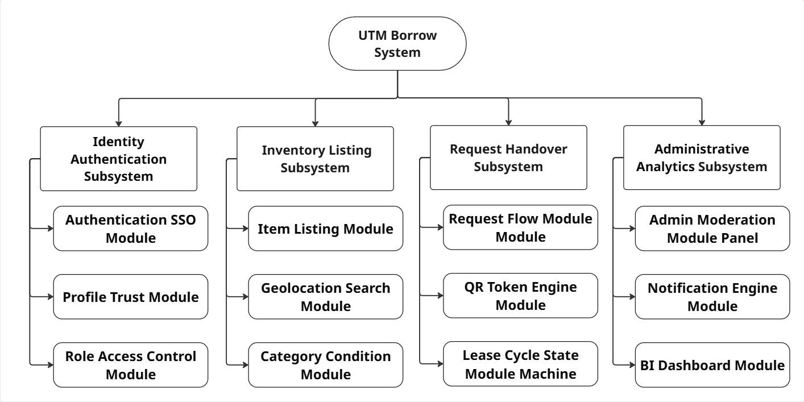
Figure 6.1.0.1:: Overview of UTM Borrow Subsystems and Modules
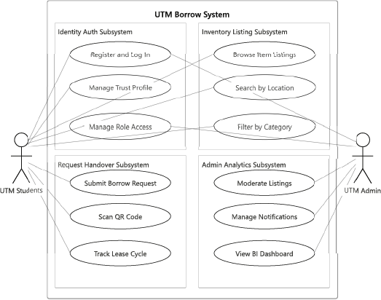
Figure 6.1.0.2: Use Case Diagram of UTM Borrow

Subsystem | Use Cases | Derived From
Identity Auth | Register and Log In, Manage Trust Profile, Manage Role Access | Auth SSO, Profile Trust, Role Access Control modules
Inventory Listing | Browse Item Listings, Search by Location, Filter by Category | Item Listing, Geolocation, Category Condition modules
Request Handover | Submit Borrow Request, Scan QR Code, Track Lease Cycle | Request Flow, QR Token Engine, Lease Cycle State modules
Admin Analytics | Moderate Listings, Manage Notifications, View BI Dashboard | Admin Moderation, Notification Engine, BI Dashboard modules
Figure 6.1.0.3:Subsystems & Use Cases Table

Identity Authentication Subsystem
Responsible for secure login, UTM-SSO integration, Role-Based Access Control (RBAC), and user "Trust Merit" profiles to ensure community integrity.
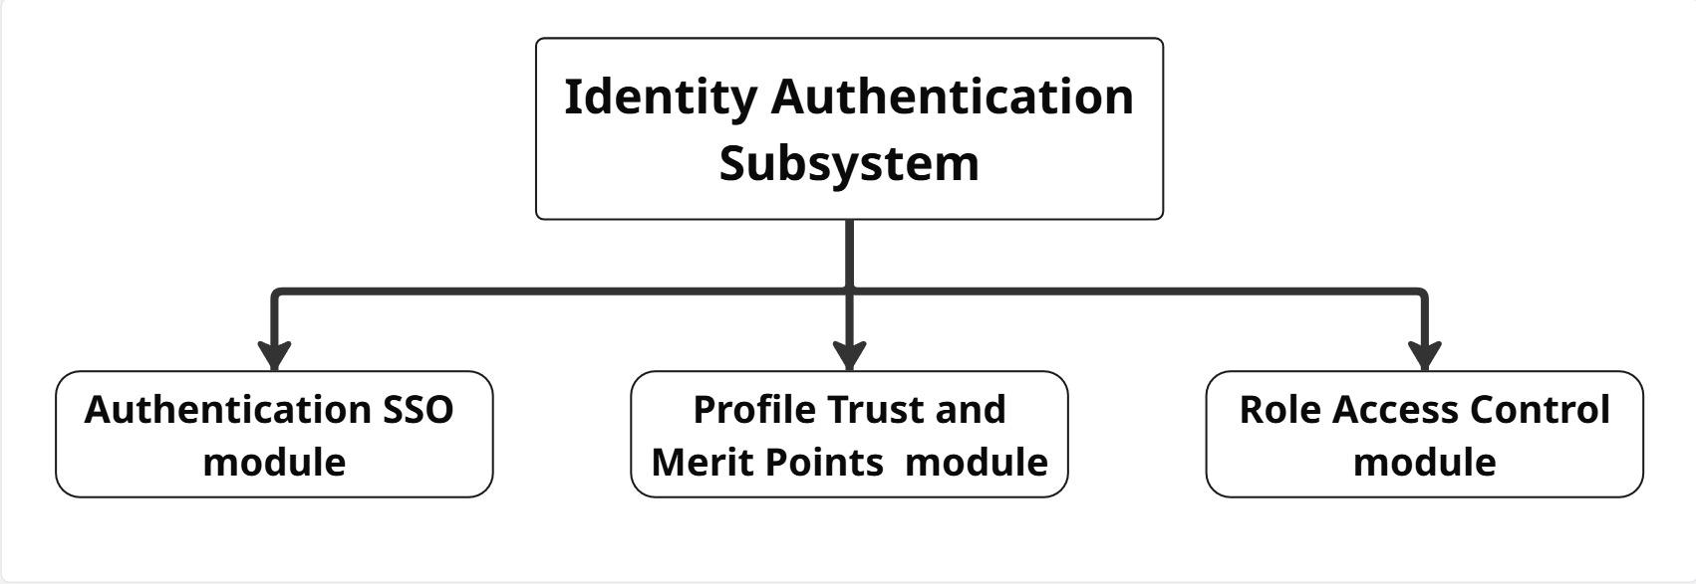
Figure 6.1 :

Authentication SSO Module
You have to log in using your official UTM student email. This makes sure no strangers can use the app.

Profile Trust and Merit Points Module
Users get "good points" for returning things on time and in good shape. These points show up on your profile so others know you are honest.

Role Access Control (RBAC) Module
The app has different settings for borrowers, lenders, and the staff who manage the system to keep everything organized.

Inventory and Listing Subsystem
Responsible for the categorization of resources, photo documentation of item condition, and the location-based search engine for proximity-based borrowing.
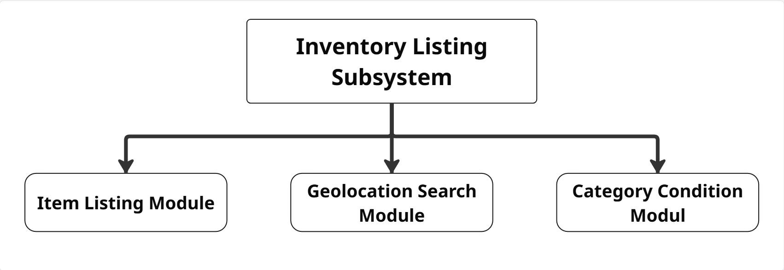
Figure 6.2.1:

Item Listing and Photo Module
Lenders can upload pictures and write a short note about the item they are sharing and how much it is worth.
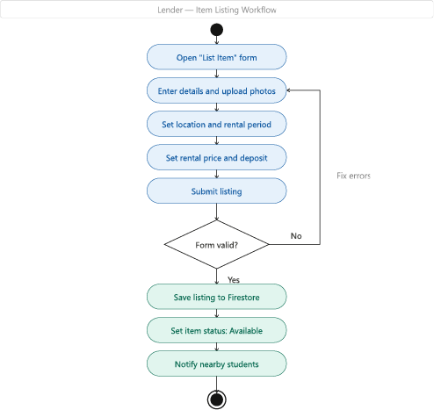

Geolocation Search Module
Borrowers can look for things in their own dorm (like KTF or KDI) or their own faculty area so they don't have to walk far to get them.

Category and Condition Metadata Module
Everything is put into groups like Lab Tools or Books. It also uses labels like "New" or "Used" so the borrower knows what to expect.

Request and Handover Subsystem
Responsible for the borrowing request workflow, QR-token generation for safe exchange, and the lifecycle tracking of item status (Available vs. In-Use).
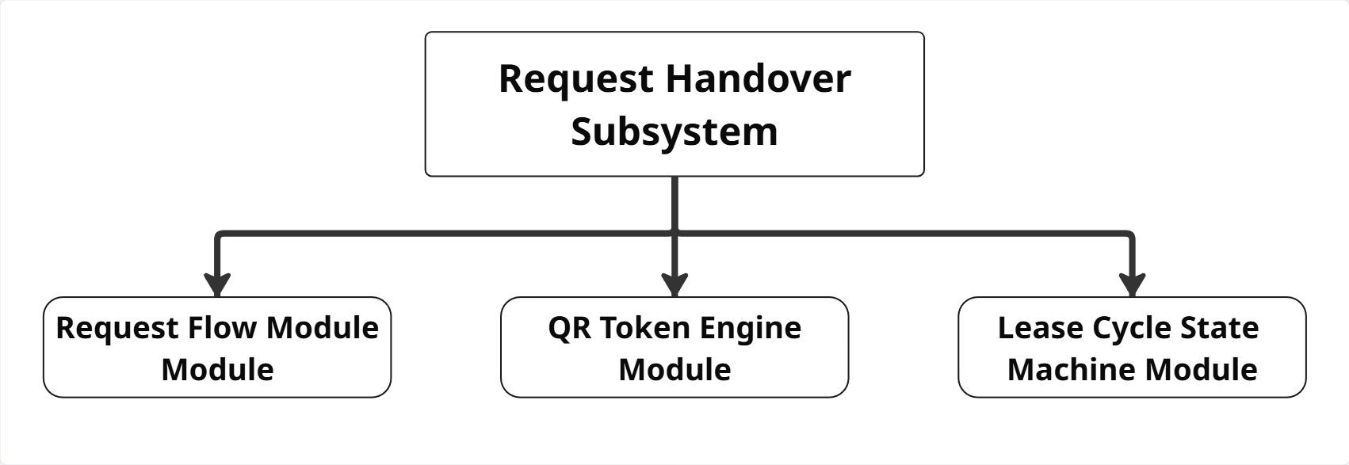
Figure 6.3.1:

Request Workflow and Insurance Fee Module
This handles the "deal" between students. It can include a small deposit to protect the owner if the item gets lost or broken.

QR Token Engine Module
The app makes a special QR code. When you meet, the lender scans the borrower's phone to prove the item was actually handed over.

Lease Cycle State Machine Module
A simple system that follows the item to show exactly where it is and if it is being used or returned.
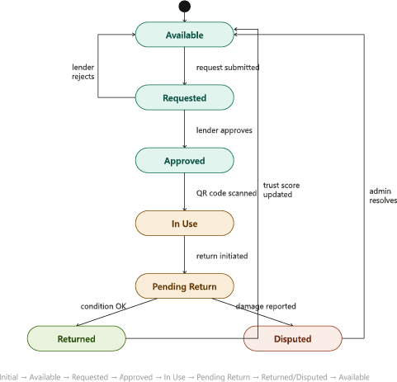

Administrative Analytics Subsystem
Responsible for moderating the marketplace, managing notifications, and visualizing environmental impact data through a BI sustainability dashboard.
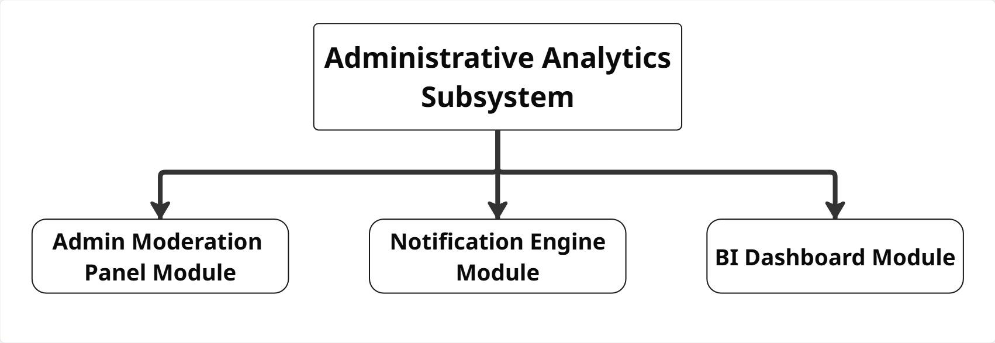
Figure 6.4.1:

Admin Moderation Panel Module
A main screen for staff to fix problems, look at reports, or block people who break the rules.

Firebase Notification Engine Module
The app sends quick alerts to your phone to tell you about a new request, a message, or a return deadline that is coming soon.

BI Sustainability Dashboard Module
A screen that shows cool facts, like how much total money UTM students saved and how much waste was stopped by sharing.

PROPOSED TECHNOLOGY AND TOOLS USED

Modeling & Project Management Tools
To meet the requirement of producing a high-fidelity prototype through a sequential design process, the team will utilize modern, visually-focused platforms rather than a deployable coding environment.

- Figma: The primary workspace for collaborative front-end UI design and building the interactive, clickable high-fidelity prototype (Weeks 12-13) that simulates the user journey.

- Generative AI (ChatGPT/Claude): In compliance with the "Modern Requirements with Gen.AI" course standard, LLMs will be utilized to safely generate comprehensive system functional requirements, edge-case user personas, and state machine condition suggestions.

Project Management and Collaboration (Jira, GitHub, Visual Paradigm)
Visual Paradigm: The mandatory system architecture tool that will be used during the Analysis & Design Phase (Weeks 7-9) to formulate exact UML schemas, including Use Case, Sequence, and Class diagrams.

Jira & GitHub: Jira will act as the Agile-hybrid project management board to track weekly task deliverables among the four members. GitHub will serve as a cloud-based repository for the systematic version control of project documentation, UML exports, and prototype version links.

PROJECT BENEFITS
Starting the UTM Borrow System gives many advantages to students, the staff, and the university's goals for a clean campus.

Benefits for UTM Students (Financial & Space)
The biggest win is for the students. By switching from a "Buy" habit to a "Borrow" habit, students save a lot of money on tools they only need once. This helps students who don't have much money to get textbooks and tools without high costs. Also, dorm rooms are very small. This app helps students live with less "clutter" because they don't have to keep big items in their rooms that they only use once a year.

Benefits for UTM Administration and UTMCS
For the university staff, this app is a safe and organized way to share things compared to messy Telegram or WhatsApp groups. Because only "verified" people can join, the university has less spam in its official chats. It also stops outsiders from coming onto campus to trade things, because everyone must log in with their SSO ID. This gives the university more control over student activities.

Environmental Impact for the University
This system moves the campus closer to being a "Zero Waste" community. Every item borrowed instead of bought new helps the planet. By making things like laptop stands, calculators, and suits last longer on campus, the university lowers its waste. The "Sustainability Dashboard" gives UTM real data to prove they are helping the world and meeting the UN Sustainable Development Goals (SDG 12)
  - Entrepreneurial Opportunity and Monetization
Although UTM Borrow aims to promote a sustainable, circular economy on campus, the platform offers significant entrepreneurial and monetization mechanisms designed to keep the system financially viable:
    - Featured Item Micro-fees: Lenders who provide highly sought-after assets (such as graphic calculators during midterms or formal attire during thesis week) can pay a micro-fee (e.g., RM1.00) to feature or "boost" their items to the top of the campus search registry.
    - Overdue Penalty Revenue Sharing: To enforce compliance, borrowers failing to meet their lease return time will trigger a daily automated deduction from their linked student wallet. A margin of this penalty is routed to the platform for server maintenance, while the remainder is passed to the lender for their inconvenience.
    - Security Deposit Intermediary Hold: The application requires high-value handovers to initiate an escrow hold on funds. Holding these funds enables the platform to ensure immediate compensation in the event of documented damage during the return scanning phase.

PROJECT SCHEDULE

Phase | Weeks | Tasks | Deliverables | Responsible
Requirements | Week 1-3 | Literature review, questionnaire design, data collection (30+ responses), stakeholder analysis | Requirement Specification Document, Survey Analysis Report | All members
Analysis | Week 4-6 | Use case diagrams, sequence diagrams, class diagrams for each subsystem | UML Diagrams (Visual Paradigm) | Individual subsystem owners
Design | Week 7-9 | UI/UX wireframes, Figma prototype, system architecture design | High-fidelity interactive prototype (Figma) | All members (led by Inventory & Listing owner)
Prototyping | Week 10-12 | Interactive prototype completion, user flow testing, iteration | Final clickable prototype with all 4 subsystems | All members
Testing | Week 13-14 | Peer-to-peer testing, bug fixes, documentation finalization | Final Project Proposal, Testing Report | All members

TEAM MEMBERS AND ROLES
To ensure specialized focus, each team member is assigned as the "Sub-system Owner" for one of the four core subsystems. They are responsible for the Requirements, design, prototype and testing of their specific Subsystem.

Subsystems and Responsible Team Members
Member Name | Responsible Subsystem | Core Technical Focus
MOHAMMED MOHSEN MOHAMMED ALSAKKAF | Identity & Authentication | QR Token Engine, Lease State Machine, and Insurance Fee logic.
MUAZ IBNE AHMED | Inventory & Listing | UTM SSO Integration, Merit Point Engine, and Role-Based Access.
AHMAT MAHAMAT MOURDJI MOUSTAPHA | Request & Handover | Item digitization, Geolocation filtering, and Category management.
TO BE ASSIGNED | Admin Analytics | Firebase Notification system and BI Sustainability Dashboard.

Waterfall Phase Responsibilities
- Requirement Phase:
- All members participate in data collection.
- Member-A & Member-B draft the System Functional Requirements.
- Aina & Jia Ying finalize the non-functional requirements and community personas.
- Analysis & Design Phase:
- Each member creates the UML (Use Case, Sequence, Class Diagrams) for their own module.
- Member-C ( Inventory Listing Subsystem) leads the Figma UI layout consistency to ensure the whole app looks professional.
- Member-A ( Request Handover Subsystem) defines the State Machine logic for item transfers.
- Implementation & Coding Phase:
- Each member develops their module's frontend (React Native) and connects it to the Backend.
- Member-B (Identity Authentication Subsystem) manages the shared User Database on Firebase to ensure secure data access for the other 3 modules.
- Testing:
- The team performs "Peer-to-Peer Testing," where Members test a module they did NOT code to find bugs (e.g.,Member-A tests Member-D's Identity Authentication Subsystem module).
- Member-D (Administrative Analytics Subsystem) handles the final notification testing and reporting dashboard validation.

INDIVIDUAL SCHEDULE
Describe here…

MOHAMMED MOHSEN MOHAMMED ALSAKKAF — : Identity Authentication

MUAZ IBNE AHMED — : Inventory and Listing

AHMAT MAHAMAT MOURDJI MOUSTAPHA — : Request and Handover

Flexible —: Administrative Analytics

